WIREFRAME DOCUMEMT

BANK CREDIT RISK PREDICTION

# **DOCUMENT VERSION CONTROL**

|  |  |  |  |
| --- | --- | --- | --- |
| DATE ISSUED | VERSION | DESCRIPTION | AUTHOR |
|  | V1.0 | WIREFRAME DOCUMENT-V1.0 | ADHIRAJ SINGH SHEKHAWAT |

**Homepage**

Homepage consists of single page having different input section and submit button. The page designed in such way that user can inserts their inputs according to their health status. There are 20 input sections in the homepage where the user will have to enter the correct entries as per their credit risk

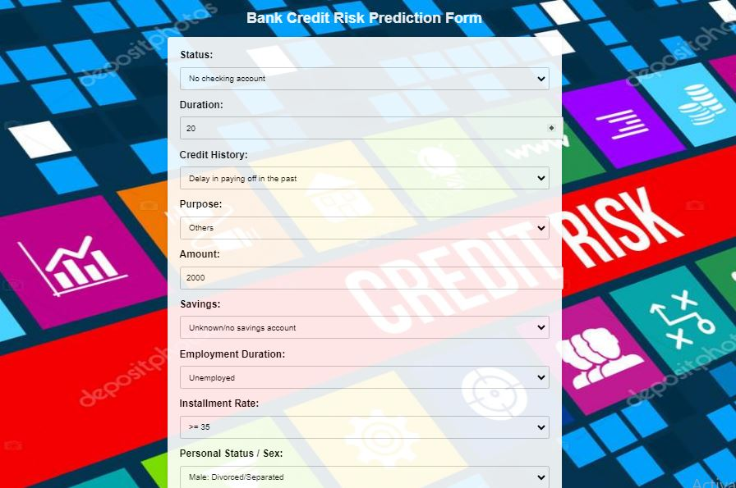

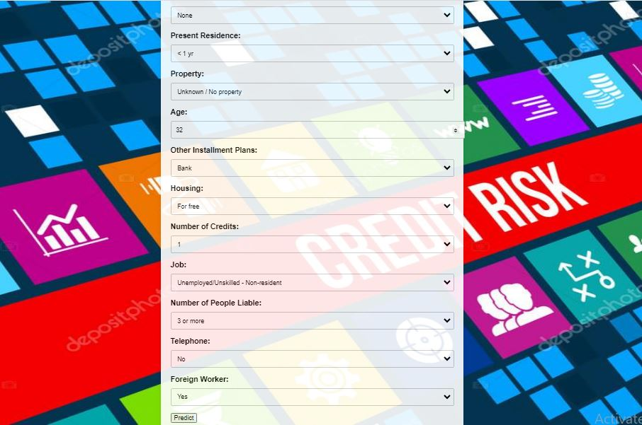

After filling the above information webpage looks like:

